Does Electricity Move Better through Thick Wires or Thin Ones?
Print
Collect It!
Email Twitter
Science Fair Survival Guide
Join now and get it free!
Buy this book »

- Very poor
- Poor
- Good
- Very good
- Excellent
based on 314 ratings
Source: John Wiley & Sons, Inc.
Topics Science Fair Project Ideas, Middle School, Fifth Grade, Elementary School, Electricity

Talk It Over
Why do you plug lamps, washing machines, and other electrical appliances into wall sockets? Inside the cords of such devices are metal wires that electric current moves through. Can current move faster, better, or easier if the wires are thick or thin?

Get
- Plastic straw
- 2 D batteries
- Scissors
- Electrical tape
- A medium steel wool pad
- 2 flashlight bulbs

Go
- Cut 2 pieces of straw the same length as the batteries. Tape them to the batteries, like this:
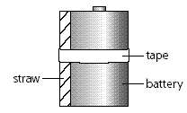
- Pull a few strands from the steel wool pad. Roll them lengthwise between your hands (as you would modeling clay) to make a thin roll of wire. Repeat, but with more strands, to make a thicker wire. Thread the wires through the straws, leaving exposed ends, like this:
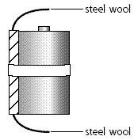
- Tape one end of each wire to the flat end (negative terminal) of a battery, like this:
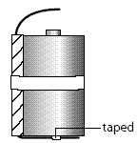
- Twist the other end of each steel wire around a bulb and secure with tape. Don't let the tape cover the base of the bulb.
- Stand the 2 batteries side by side. Holding the bulbs by the glass part, touch the base of the bulb to the "bump" on the positive terminal of the battery, like this:
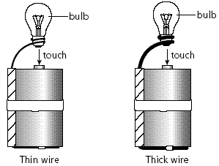
- Which bulb glows brighter? Suggest a reason to explain what you see.
- As soon as you see a difference, pull the bulbs away from the battery terminals. Hold them too long and you'll burn out the bulb and run down the battery.

Stay Safe
Hold the bulbs only by the glass part. Don't touch the base of the bulb or the steel wool. They get hot!

Go Easy
What materials allow electric current to move? What materials slow or stop it? Use the same setup as above, but with only one battery and bulb. Don't use steel wool. Instead, thread the materials you want to test through the straw and observe whether the bulb lights. You might try string, plastic wrap, copper wire, or a strip of aluminum foil.

Go Far
The opposition of a material to the flow of an electrical current is called resistance. It is measured in ohms. The greater the resistance (the larger the number of ohms), the less current flows. To learn more about resistance and demonstrate its effects, you can use the "Go" procedure to
- Test electrical wires of different thicknesses (called gauge) for their resistance
- Compare the resistances of wires made of different metals
- Experiment to find out how temperature affects resistance
You might also purchase an inexpensive electrical tester* and use it to measure resistance in electrical circuits you build.

Show Your Results
Put check marks in a data table like this for "Go Easy":
Material Tested | It Lights | It Doesn't Light
For "Go," draw diagrams of your setups and observations. Write a few sentences telling what you saw and giving your explanation. Put your setups with your display so others can try the experiment for themselves.
For "Go Far," make a bar graph showing how the variable you studied relates to resistance. For example, you might make a bar graph of the ohms of resistance you measured using different gauges of copper wire.*

Tips and Tricks
Depleted batteries and burned out bulbs can prevent bulbs from lighting, but if you're working with new materials and getting no glow, something is probably loose somewhere. Check taped connections to make sure wires are firmly attached to battery and bulb.

